Screen Cropper

**Graduate Project for SER 598**

Submitted by: -

Nitin Goel

1209387436

# Introduction

This app is built on android platform for API 23 i.e. Android 6.0 (Marshmallow).

The base app for this app is the app submitted in Assignment 7 for Android.

New Concepts Added to the app include:

* Floating Window
* Screen Capturing
* File Handling (Saving image to gallery)

Floating Window is enables developer to design apps with functionality like always-on-top windows, allowing user with a rich experience of multi-tasking (as the user can have multiple floating windows on the screen).

Screen Capturing is another android’s feature which enable us to take screenshot for the current view and save it.

File Handling is done to save the received bitmap screenshot into the directory where android stores its images allowing user easy access to the save image file).

Along with all this the app uses API 23’s runtime permission feature where user is asked for permissions to launch a floating window and to store file in Gallery.

# Working

1. This app loads like the app in Assignment 7 (See Figure 1).

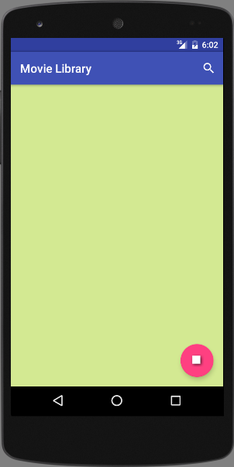 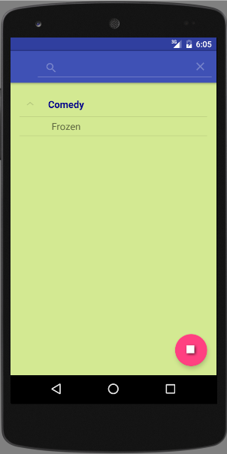

Figure 1 Figure

1. Let’s add a movie to it say ‘frozen’ (See Figure 2).
2. Now let’s use the add feature to the app using the floating action button on the bottom right corner of the screen (See figure 3).

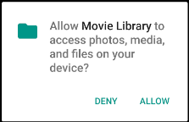 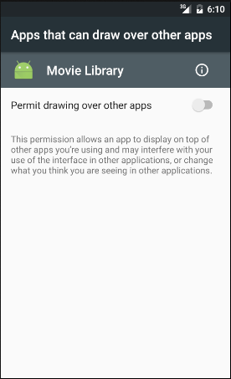

Figure Figure

1. It prompts for permissions to save image in gallery and to allow floating window on your device (See figure 4).
2. Once we give permission and again tap on the floating action button (or ‘SCREENSHOT’ on Menu Bar), a floating window appears on top of the activity (See figure 5). This window can be:
   1. Resized using ‘+’ and ‘–’ image buttons on the window
   2. Moved around by tapping it and then dragging it.
   3. Closed by touching the red cross image button on the window.

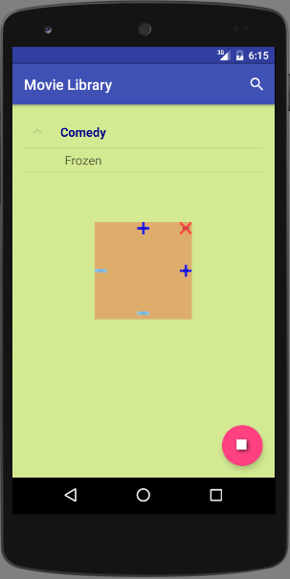 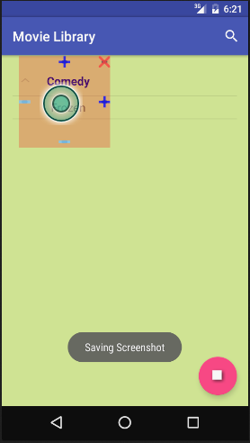

Figure Figure

1. After dragging the floating window to the desired location and then double tapping in the center portion of the window, we get a toast stating “Saving Screenshot” with this toast it informs the user that the current section of the screen under the floating window is captured and saved in gallery (See figure 6).

Note, that even after the screenshot is taken the floating window stays up and if we double tap again then the previous file is replaced in the gallery. If a new file is to be created, then the window should be reopened (This is done to avoid unnecessary screenshot’s created during resizing of the window).

Also the app closes the floating window when we switch between activities (this is done to avoid confusion for screenshot).

1. We could find this image in the Gallery (See figure 7)

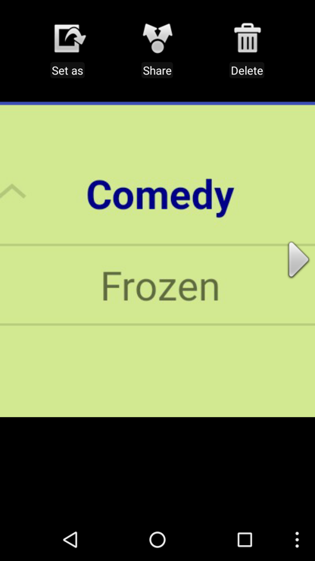

Figure

1. Here is another example (see below)

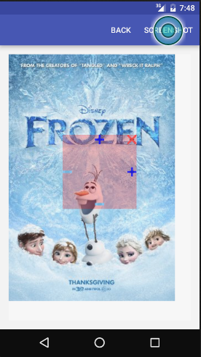 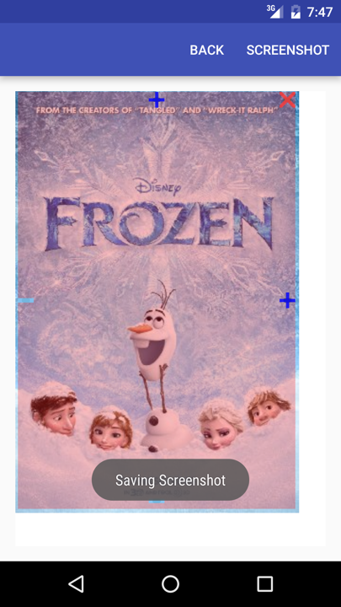 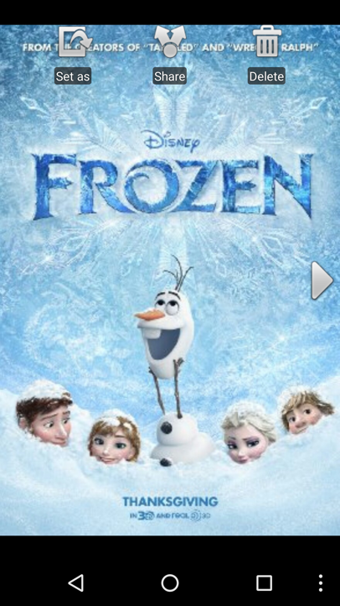

NOTE: Rest of the APP work same at in Assignment 7